以下為本樂團6/10/2019‘結他輕曲伴秋夜’ 音樂會之2種退票方案，請於31/10/2019 或之前申請退票：

1. 最快可於18/10/2019 (星期五) 7:00 pm – 7:45 pm在大會堂低座大堂近Deli and Wine攜同門票正本，有專人安排直接退票取回金額。(請預先與丁小姐登記，電話: 59345583)

2. 請電郵以下資料*至vihuelaguitar@yahoo.com.hk，門票一經確認後，會於31/10/2019限期後的一個星期內，將金額入落持票人戶口。(請提供英文全名及戶口號碼)

衷心多謝各位的支持！

* 完整門票影像：正面(清楚顯示購票日期和bar code)及反摺票尾到正面(清楚顯示serial number和bar code)
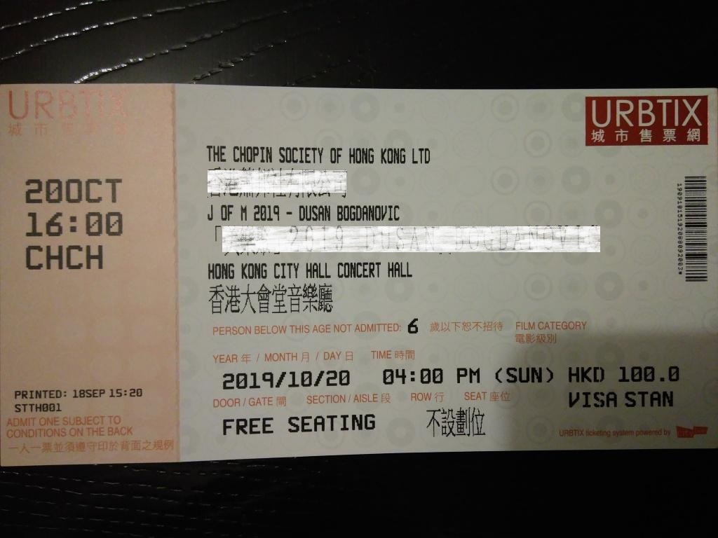樣本1 Sample 1
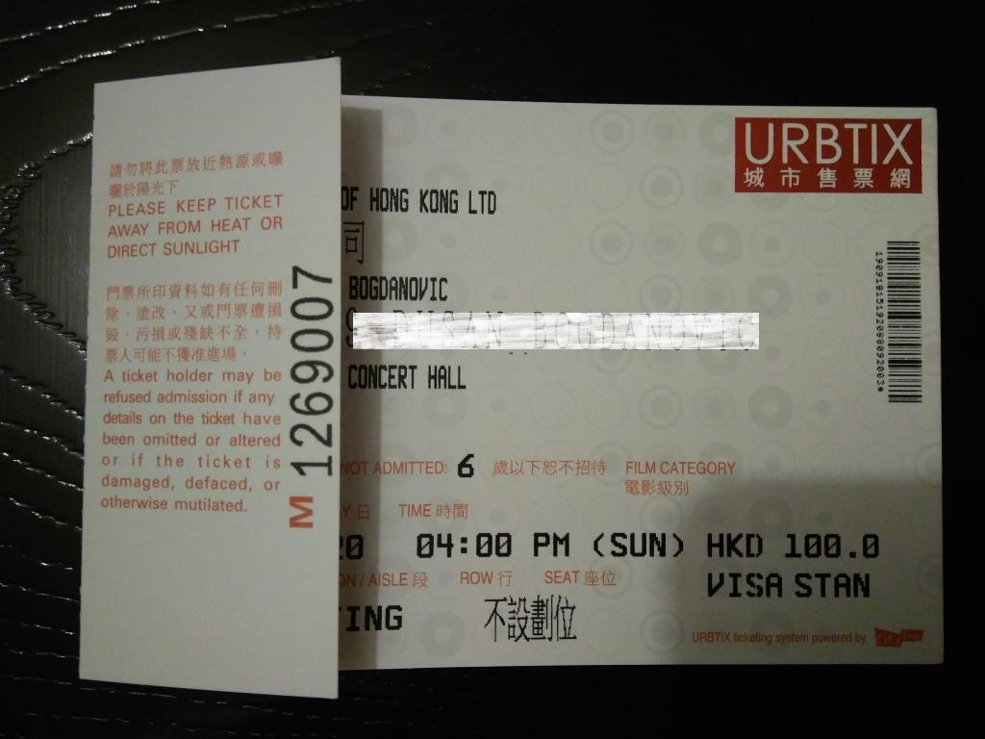樣本2 Sample 2

We would like to offer the following two ways for our audiences to claim the ticket money for our cancelled concert ‘Guitar Music in Autumn’ on 6/10/2019:

1. You may claim the money in cash from our member who will stand by near Deli and Wine at the foyer of City Hall, Low Block from 7 pm to 7.45 pm on 18/10/2019 (Friday). Please register with Molly on phone no. 59345583 beforehand.

2. You may e-mail us at vihuelaguitar@yahoo.com.hk providing your full name and your account number and also two photos of your ticket as per the sample above. Please make sure the photos can clearly show the date that the ticket was printed, the bar code and the serial number. The ticket money will be transferred to the account provided within one week from 31/10/2019 which is the deadline for claiming the refund.

Many thanks for your support and we hope to see you in our concert again.

